AWS Mini Projects Mass Emailing Using AWS Lambda

AWS Lambda Demonstration 1 – Sending an Email on Addition of User Data in the DynamoDB Table

Architectural Diagram:

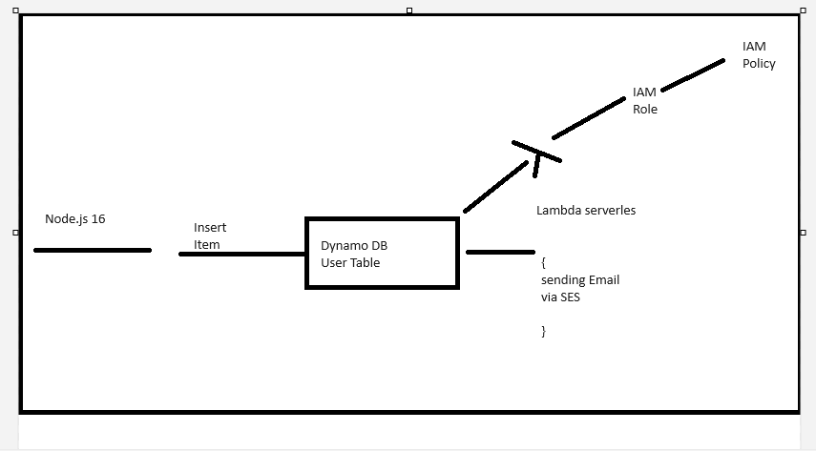

**AWS Services: DynamoDB, Lambda, IAM,SNS and SES**

**Solution Steps:**

Step 1: Go to the SES Console and click on Verify a New Email Address.

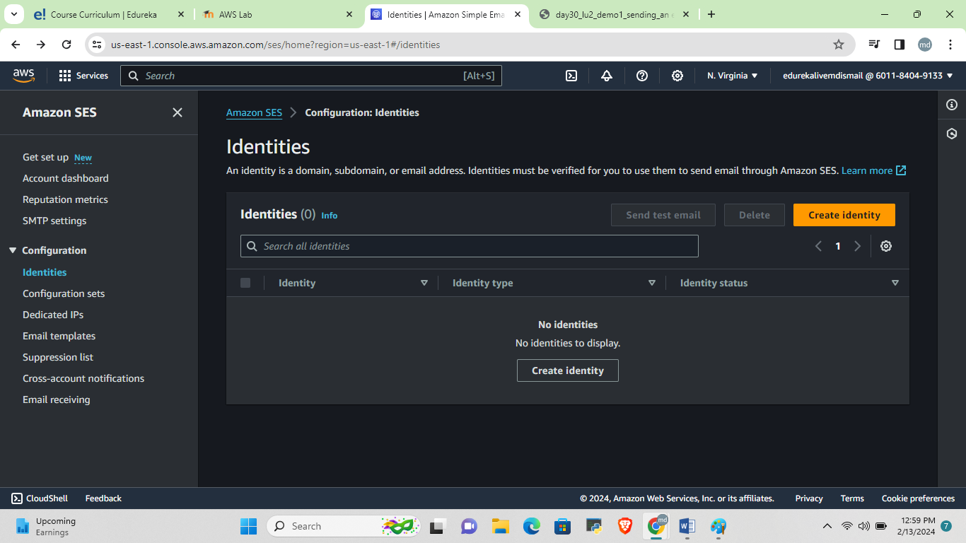

Step 2: Enter the email address and click on Verify This Email Address.

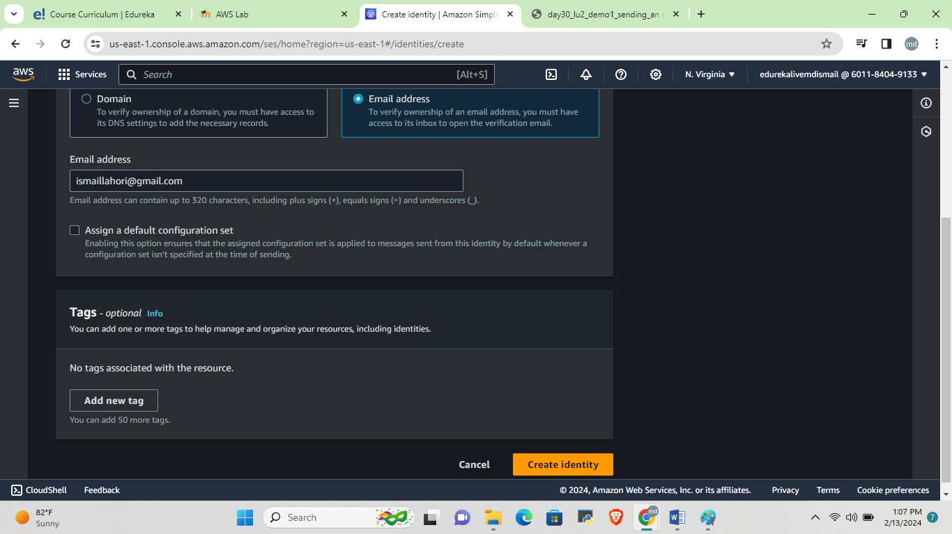

Step 3: An email will be sent to this address with a link for the sake of verification. Click on Close.

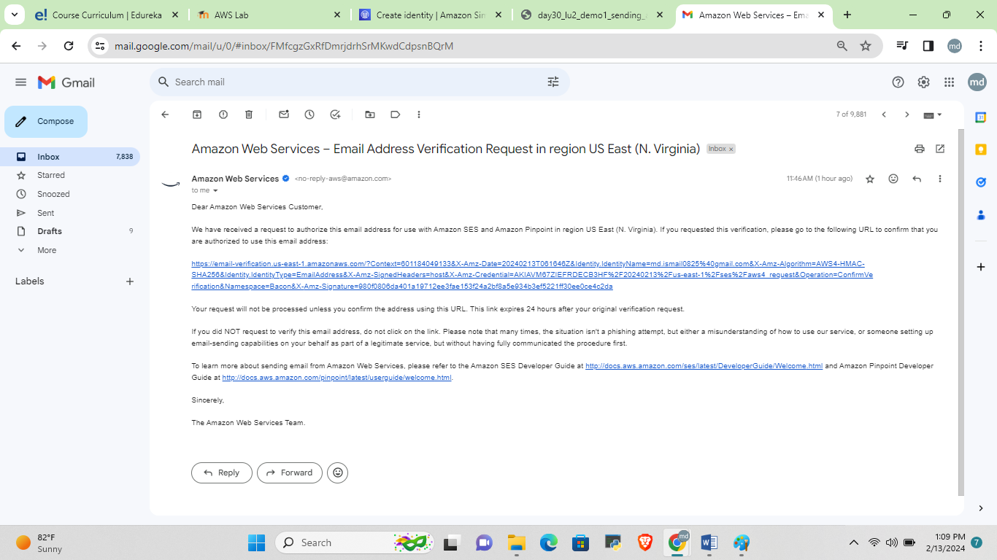

Step 5: Follow the same steps and verify another email address. Note that One would function as the sender’s email address and the other, as the receiver’s email address.

Step 6: Now it is time to create an IAM Role for Lambda. Go to the IAM Management Console, click on Roles, and click on Create role.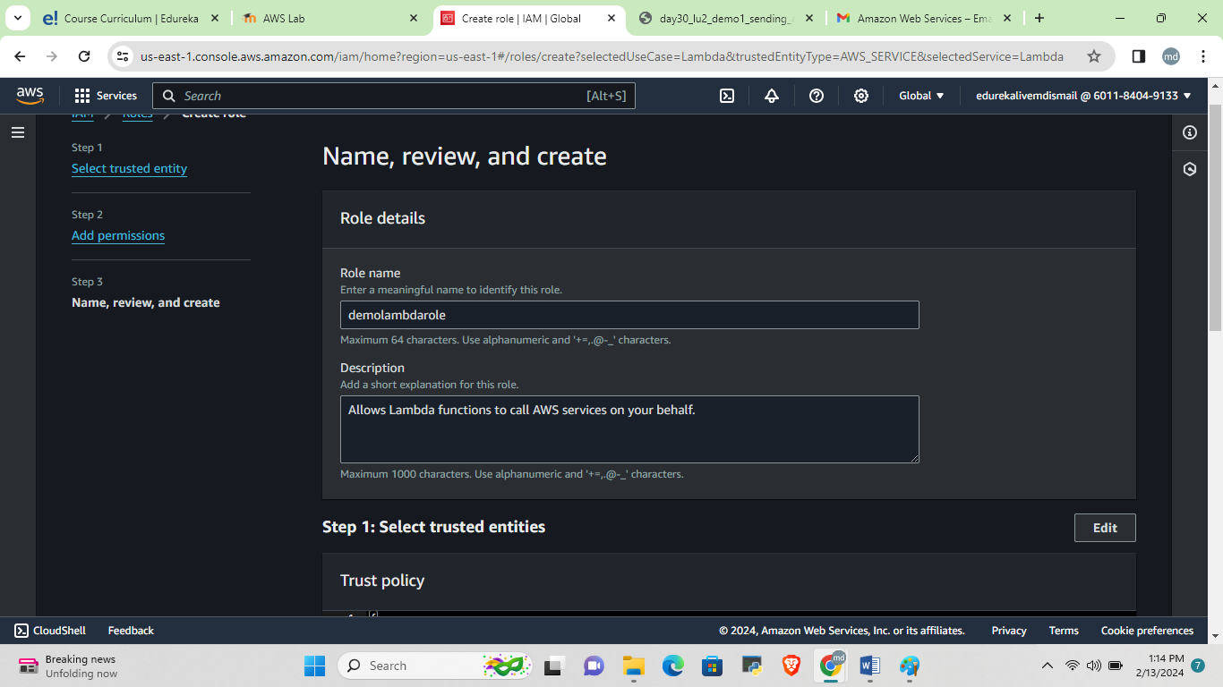

This is the creating of IAM role that is demoLambda and given permission is

Step 7: Select Lambda as the service which is going to use this, Role. Click on

Next: Permissions.

AWSDynamoDBlambda,

SNSFullAccess

SESFullAccess

Step 8: Select the AWSLambdaDynamoDBExecutionRole and AmazonSESFullAccess policies and click on Next: Tags.

Step 11: Go to the Lambda Management Console and click on Create function.

Step 12: Enter the function name, select the role, as NodeJS 16.x and select the role created earlier.

Step 13: Copy the below code. Ensure replacing the from and to address with the email address verified earlier. And finally, click on Save.

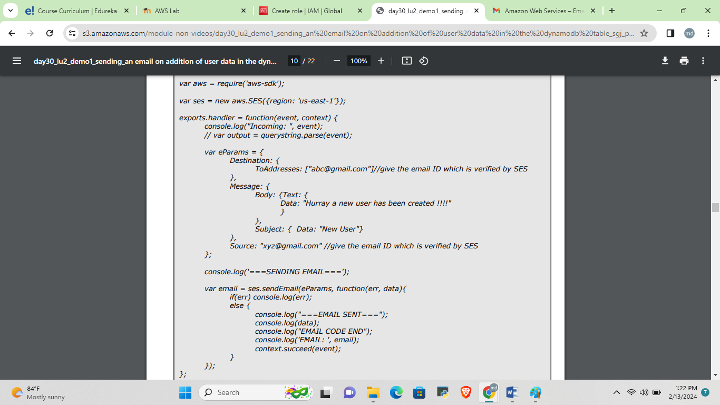

Deploy the code in lambda server

Step 25: Check your email, and there should be an email from the SES service which has been triggered by the Lambda function. The function in the Lambda function can be replaced with any code for integration with other applications via AWS SQS Service.

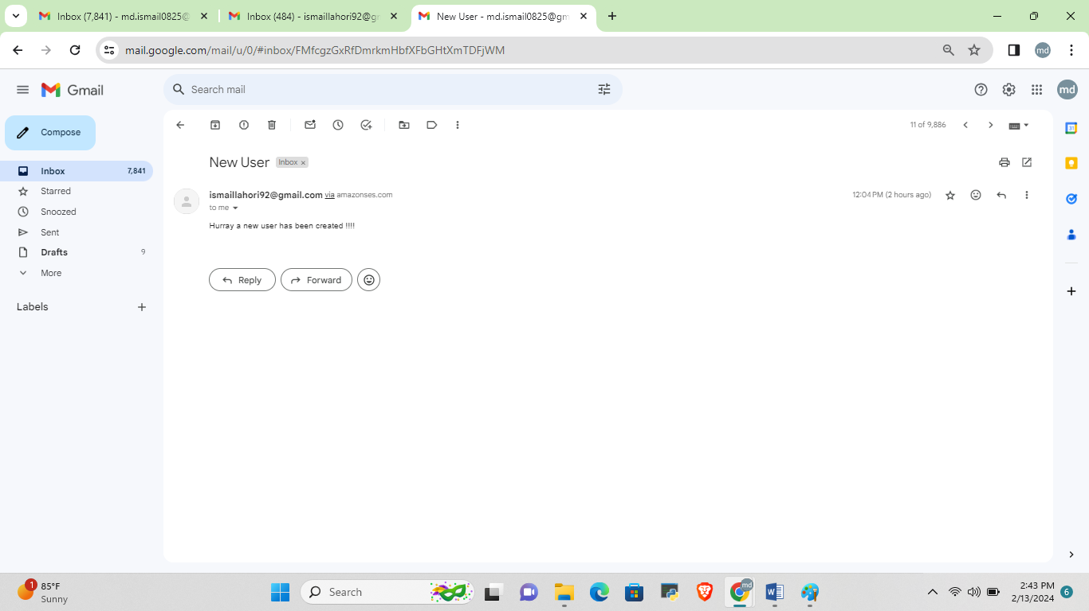

**Conclusion**

We have successfully sent an Email on the Addition of User Data in the DynamoDB Table.